**Database Design Project Requirements (Max, Henry, and Cass)**

**Project Overview:**

The Inventory Management System aims to help a retail store track and manage its products, orders, and suppliers. Customers can view available inventory, employees and managers can update inventory data based on their permissions, and the owner can generate inventory reports for auditing.

**Key Stakeholders:**

* **Customers:** End-users who interact with the system to browse and view product details.
* **Employees:** Handle things like checking inventory levels and updating product quantities.
* **Managers:** Manage stock levels, update product information, place orders with suppliers, and handle incoming stock. They have elevated system privileges compared to employees.
* **Owner:** Has the highest level of access within the system and can generate inventory reports.

**Functions:**

* Manage products, orders, suppliers, and inventory levels.
* Allow customers to view available inventory.
* Update inventory data.
* Generate inventory reports for stock audits and monitoring.

**Key Entities:**

1. **Product:**
   * Attributes: product_id, product_name, category, price, quantity_in_stock, supplier_id
   * Relationships: A product is supplied by one supplier and can be part of multiple orders.
2. **Supplier:**
   * Attributes: supplier_id, supplier_name, contact_info
   * Relationships: A supplier can provide many products and have multiple orders placed with them.
3. **Order:**
   * Attributes: order_id, order_date, supplier_id, total_amount
   * Relationships: An order is placed with on supplier and can contain multiple products.
4. **Order Detail:**
   * Attributes: detail_id, order_id, product_id, quantity_ordered, price_at_order_time
   * Relationships: Connects Order and Product, containing the quantity of each product in an order and its price at the time of ordering.
5. **User:**
   * Attributes: user_id, username, password, role, contact_info
   * Relationships: A user (owner, manager, or employee) can generate inventory reports and manage product/order data based on their role.
6. **Inventory Report:**
   * Attributes: report_id, report_date, report_data
   * Relationships: An inventory report is generated by a user to track stock levels and monitor the inventory.

**Assumptions:**

* Each product is supplied by one supplier.
* A product can appear in multiple orders.
* Employees can only modify inventory based on their role and permissions.
* Orders are always placed with a specific supplier.
* The store owner can generate inventory reports for auditing and analysis.

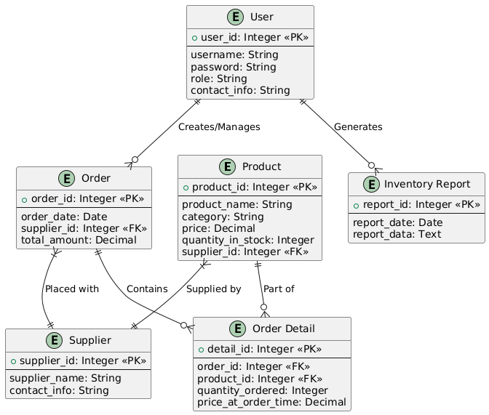**ER Diagram:**

**Relationships:**

* One Product is supplied by one Supplier.
* One Product can be part of many OrderDetails.
* One Order can contain many OrderDetails.
* One Order is placed with one Supplier.
* One User can generate many InventoryReports.
* One User can create/manage many Orders.